New England Region Airport Certification Bulletin


Certification Bulletin
FY 2011 – Issue 8
Issued October 14, 2010
New England Region, Airports Division
Airport Certification Team
8-01-2011

The New England Region Airports Division is sending this bulletin to State Aviation agencies and Airport Managers in Connecticut, Rhode Island, Massachusetts, Maine, New Hampshire, and Vermont. It contains information and guidance about Airport Safety and the Airport Certification Safety Program that may be useful to people with various interests in your organization. Please distribute this bulletin to persons at your airports

SUBJECT: Painting SPHPS and NOTAMS

BACKGROUND:
When painting surface painted holding position signs (SPHPS) it is a recommended best practice to allow the red paint to cure for 24 hours before painting the white inscriptions. This procedure will result in a better bond between the white inscription and the red background and will prevent flaking of the marking. A future change will be made to AC 150/5370-10E, Standards for Specifying Construction of Airports, to address this issue.
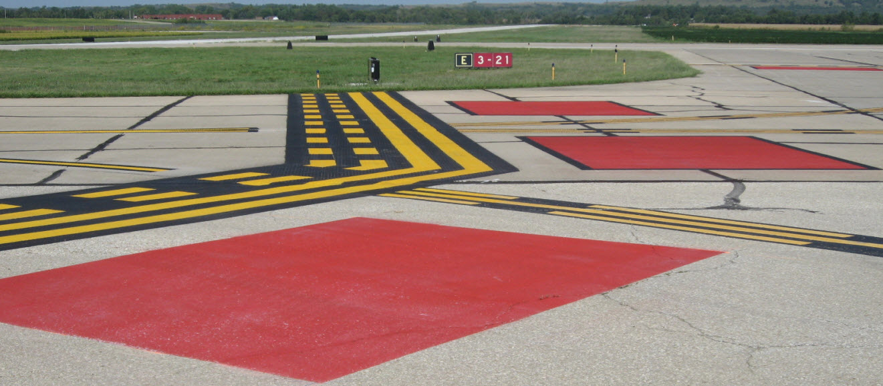
SPHPS are required by Part 139.311(b)(1)(ii), as documented in AC 150/5340-1K, Standards for Airport Markings, red safety box on page 38.

Part 139.339(c)(6) requires that each certificate shall,
(c) In complying with paragraph (a) of this section, provide information on the following airport conditions that may affect the safe operations of air carriers:
(6) Malfunction of any lighting system, holding position signs, or ILS critical area signs required by Sec. 139.311.

ACTION REQUIRED:
During the curing period when SPHPS are missing the white inscriptions, a NOTAM must be issued to notify pilots of the non-standard markings.

Submit NOTAMS to Lockheed Martin Flight Services for out of service SPHPS in the following format:

(Airport Identifier) TWY (affected TWY) SURFACE PAINTED HOLDING POSITION SIGNS (AT affected RWY) NONSTD (reason)
Example
BOS TWY E, K SURFACE PAINTED HOLDING POSITION SIGNS AT RWY 4L/22R NONSTD DUE TO REPAINTING
The affected TWY is mandatory and the affected runway and reason may be included for clarification. If out of service or non-standard SPHPS are located on more than one runway, separate NOTAMS should be issued for each runway.

If you have questions concerning this bulletin, contact either Lead Airport Certification Inspector, Laurie Dragonas at 781.238.7630 or Airport Certification Inspector, Kelly Slusarski at 781.238.7632.

